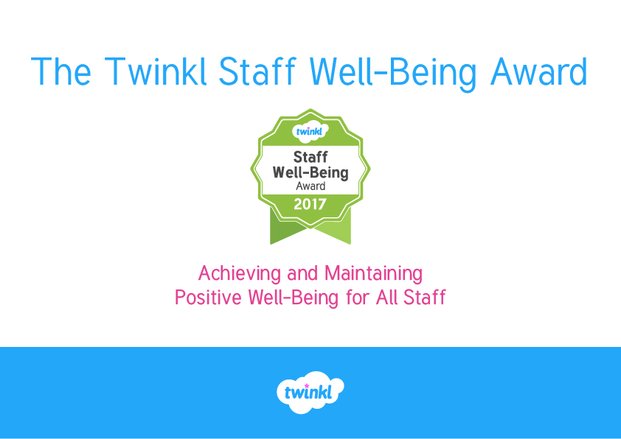

# Twinkl staff well-being award entry document

At Twinkl, we believe that healthy and happy staff lead to a positive environment, where pupils come to school eager to learn and progress. Not only is making provision for staff well-being helping to support your hardworking staff, it also impacts on the success of the school which, in turn, benefits the whole community.

We have split staff well-being into three areas:

1. Leadership
2. Policy Development
3. Staff Culture

Use this Award Entry document to record and update your school’s progress under these three headings. As you enter information it will help you to work out which areas you need to improve and how to do it, in order to gain enough evidence to achieve the award.

Once you’ve downloaded the Twinkl Staff Well-Being Award Entry document, you can start completing it by checking the boxes as “yes”, “no” or “developing”. This will allow you to see which areas need more work. Any examples that cannot be fitted onto the end of the document should be photographed/scanned and emailed to [awards@twinkl.co.uk](mailto:awards@twinkl.co.uk).

You can submit your Twinkl Staff Well-Being Award Entry at any time [via our online form](http://www.twinkl.co.uk/well-being-award) and will receive a decision within four weeks as to whether you have achieved the award, or which areas need improvement in order to achieve it.

When your Twinkl Staff Well-Being Award has been approved, you will be sent a badge that can be added to your school website, newsletter and other marketing materials.

This award is then valid for 12 months, and you will be eligible to reapply when this time period expires. Contact [awards@twinkl.co.uk](mailto:awards@twinkl.co.uk) for further information and guidance on applications.

# FAQ

Q) Can we include further activities that we do as a school that are not mentioned here?

A) Yes of course! The more ideas the better, and we can share them with our other members as well.

Q) What will we receive as recognition of our success?

A) You will receive a Twinkl Staff Well-Being logo to use on your website and other printed materials. We will also supply a certificate that you can use in school.

Q) Will my Twinkl Staff Well-Being Award expire?

A) Yes, it will only last for 12 months, at which point you will have to reapply.

Q) What if my application is declined and we do not achieve the award?

A) Schools are invited to reapply when they have gathered more evidence of their progress against the assessment criteria.

Q) Do we need evidence for every single area to be awarded a Twinkl Staff Well Being Award?

A) No. What is important here is the overall picture of staff well-being and a positive school ethos geared towards encouraging a good work/life balance.

Q) How do I submit evidence?

A) Some evidence can be typed directly onto the form. Paper copies, displays or any other visual evidence can be scanned/photographed and sent to [awards@twinkl.co.uk](mailto:awards@twinkl.co.uk) being sure to mention the name of the school in the email.

**Contact** [**awards@twinkl.co.uk**](mailto:awards@twinkl.co.uk) **for further information and guidance on applications.**

# Help and Support

The following Twinkl resources may be helpful to you for demonstrating evidence of staff well-being.

[How to prioritise your work](http://www.twinkl.co.uk/resource/t-c-1589-how-to-prioritise-your-work)

[Staff well-being questionnaire checklist](http://www.twinkl.co.uk/resource/t-c-7289-staff-well-being-questionnaire-checklist)

[Wow you’ve been spotted colleague praise poster](http://www.twinkl.co.uk/resource/t-c-6889-wow-youve-been-spotted-colleague-praise-poster)

[Well-being stickers sticker reward charts](http://www.twinkl.co.uk/resource/t-c-7453-well-being-stickers-sticker-reward-charts)

[Staff social event calendar](http://www.twinkl.co.uk/resource/t-c-7119-staff-social-event-calendar)

[Teacher standards checklist](http://www.twinkl.co.uk/resource/t-c-7491-teacher-standards-checklist)

[PPA time to-do list for teachers](http://www.twinkl.co.uk/resource/t-c-1603-ppa-time-to-do-list-for-teachers)

[Record of continuing professional development CPD](http://www.twinkl.co.uk/resource/t-c-1610-record-of-continuing-professional-development-cpd)

[New top tips to boost your immune system poster](http://www.twinkl.co.uk/resource/t-c-6961-new-top-tips-to-boost-your-immune-system-poster)

[Top five tips to support effective assessment and marking](http://www.twinkl.co.uk/resource/t-c-1673-top-five-tips-to-support-effective-assessment-and-marking)

[School marking guidance update PowerPoint](http://www.twinkl.co.uk/resource/t2-pa-36-school-marking-guidance-update-powerpoint)

[5 top tips to build in work life balance](http://www.twinkl.co.uk/resource/t-c-1587-5-top-tips-to-build-in-work-life-balance)

[E-safety for staff in schools](http://www.twinkl.co.uk/resource/t-c-1601-e-safety-for-staff-in-schools)

[Staffroom fun ideas display posters](http://www.twinkl.co.uk/resource/ca-m-2-staffroom-fun-ideas-display-posters)

[The kind Christmas elves staff cards](http://www.twinkl.co.uk/resource/t-c-7824-the-kind-christmas-elves-staff-cards)

[Staff shout out staff room display pack](http://www.twinkl.co.uk/resource/t-c-7601-staff-shout-out-staff-room-display-pack)

Further resources are also available here:

[Pastoral support and well-being staff well-being](http://www.twinkl.co.uk/resources/ks2-class-management/keystage2-ks2-pastoral-support-and-well-being/keystage2-ks2-pastoral-support-and-well-being-staff-well-being)

# Leadership

|  |  |  |  |  |  |
| --- | --- | --- | --- | --- | --- |
| **Criteria** | **Questions to prompt discussion** | **School Evidence – Complete This Section** | | | |
| * **The school provides clear leadership to create and manage a positive environment, which enhances the emotional and psychological well-being of staff in school.** | * Is there a senior leader in place who actively manages staff well-being? * Do senior leaders meet regularly to discuss ways to support staff well-being? * Are governors involved in staff well-being? Are they encouraged to thank and support staff regularly? * Do senior leaders effectively model methods of achieving emotional and psychological well-being? | Please attach evidence at the end of this document, or email separately to [awards@twinkl.co.uk](mailto:awards@twinkl.co.uk) with your school name. | | | |
| Evidence (use a X) | **Yes** | **No** | **Developing** |
| Is there a staff well-being lead in place? (provide name) | **Name -** | | |
| Is the emotional and psychological well-being of staff monitored in a positive way by senior leaders? |  |  |  |
| Further activity not mentioned above: |  | | | | |

# Policy Development

|  |  |  |  |  |  |
| --- | --- | --- | --- | --- | --- |
| **Criteria** | **Questions to prompt discussion** | **School Evidence – Complete This Section** | | | |
| * **The school has a policy in place that actively discusses staff well-being and encourages a healthy work/life balance.** * **Pupils are aware of this policy and do their utmost to support staff to encourage staff well-being - taking responsibility for themselves as learners and members of the school community.** * **Parents are aware of expectations regarding treatment of staff.** | * Do staff understand this policy and feel it is part of the ethos of the school? * Are pupils aware of the benefits of staff well-being? (where appropriate for pupil’s understanding) * Are pupils aware of the need for staff to have a healthy work/life balance and ways in which they can help with this e.g. helping to keep work areas tidy and easy to access, peer marking, proactive learning and behaviour management? (where appropriate for pupils’ understanding.) * Are pupils aware that staff have regular preparation time and the reasons for this? | Please attach evidence at the end of this document, or email separately to [awards@twinkl.co.uk](mailto:awards@twinkl.co.uk) with your school name. | | | |
| **Evidence (use a X)** | **Yes** | **No** | **Developing** |
| Is there a staff well- being policy? (photograph and attach) |  |  |  |
| Is there a home-school agreement which outlines appropriate communication with staff? (please attach) |  |  |  |
| Is staff well-being discussed at governors’ meetings which then results in action taken? (please attach examples) |  |  |  |
| Do pupils take responsibility for looking after their classroom/shared areas? (please attach photos of rotas or displays) |  |  |  |
| Does the school council have staff well-being on their agenda? (include testimonials from the children) |  |  |  |
| Is there evidence on the school website or on newsletters of staff well-being? (please attach examples) |  |  |  |
| Does the school marking policy encourage realistic levels of feedback? |  |  |  |
| Further activity not mentioned above: |  | | | | |

# Staff Culture

|  |  |  |  |  |  |
| --- | --- | --- | --- | --- | --- |
| **Criteria** | **Questions to prompt discussion** | **School Evidence – Complete This Section** | | | |
| 1. **The school ethos, culture and environment provides a work place where all staff feel safe and well cared for.** | * Are staff regularly given questionnaires or asked about issues such as: temperature, cleanliness of the staff room and chair comfort – both in the staffroom and in classrooms? * Are hot drinks and snacks provided to staff free of charge as part of the school budget? * Is there a staffroom shout out board where staff can thank one another and congratulate each other on their achievements? * Are staff routinely thanked by the senior team, governors and each other – is this modelled effectively? * Are staff encouraged to smile and say hello? * Are extra classes and groups provided for teachers where required - e.g. a staff choir, craft clubs, exercise, relaxation and holistic therapy. * Are new staff and supply staff welcomed and introduced effectively – are they given a mentor or buddy? | Please attach evidence at the end of this document, or email separately to [awards@twinkl.co.uk](mailto:awards@twinkl.co.uk) with your school name. | | | |
| **Evidence (use a X)** | **Yes** | **No** | **Developing** |
| Are hot and cold drinks provided by school? (please attach photos) |  |  |  |
| Are fruit or other healthy foods provided for staff**?** (please attach photos) |  |  |  |
| Does the staffroom have comfortable chairs? |  |  |  |
| Do classrooms have good chairs for staff? |  |  |  |
| Does the staffroom have clean preparation areas that are maintained by cleaning staff? (please attach photo) |  |  |  |
| Is the temperature of the school (including all classrooms) neither too hot nor too cold? |  |  |  |
| Are lunch times away from classrooms seen as an integral part of staff culture? (please attach photo) |  |  |  |
| Is clean and palatable drinking water available in the staffroom at all times? (please attach photo) |  |  |  |
| Does good communication occur across the school and are staff regularly thanked by each other and their line managers? |  |  |  |
| Are extra classes and groups provided for teachers where required - e.g. a staff choir, craft clubs, exercise, relaxation and holistic therapy? (please attach photos) |  |  |  |
| 1. **All staff are encouraged to have a work/life balance and measures are put in place to ensure this happens.** | * Do the senior team model a good work/life balance effectively? * Are staff members who have a good work/life balance praised for this and asked to offer suggestions to other staff? * Is training given on achieving a good work/life balance? * Are staff supported when it comes to child care or other caring responsibilities? * Are staff encouraged to take proper breaks from school work during holidays and weekends? How is this implemented? | Is marking and planning useful to pupils and staff rather than onerous and time consuming? (please attach marking policy) |  |  |  |
| Are staff encouraged to leave on time at least one evening a week with no work to take home with them? (please attach evidence) |  |  |  |
| Is preparation time provided and protected and can it be taken at home if practical? (please attach evidence e.g. written testimonial) |  |  |  |
| Are teaching resources shared and used effectively thus preventing staff from reinventing the wheel each week? (please attach evidence e.g. written testimonial) |  |  |  |
| Are support staff not expected to work beyond the remit of their role unless they have requested to do so? (please attach evidence e.g. written testimonial) |  |  |  |
| Are staff meetings purposeful and relevant? (please attach schedule) |  |  |  |
| Is adequate notice given for observations, book audits, learning walks, parents’ evenings and data deadlines? |  |  |  |
| Are non teacher tasks; displays, photocopying and other admin tasks, managed effectively by non-teaching staff? (please attach rota) |  |  |  |
| 1. **The school provides opportunities for staff members to celebrate their achievements and life events.** | * Are staff encouraged to attend important family events? * Is there an easy and accessible application procedure that is not overly onerous, to allow staff to attend family events? | Are staff given leave time for attending graduation, funerals and weddings of close family members without question? |  |  |  |
| Are staff given leave to attend important school events of their own children e.g. nativity performances, meetings with their child’s teacher, “head teacher award” assemblies without question? |  |  |  |
| Are staff given extra support before, during and after fertility treatment/ maternity/paternity/adoption leave? (please attach letters sent/received – with permission from staff members, photos or receipts of flowers sent etc) |  |  |  |
| Are staff given extra support when their children are very young or during their teenage years (or other times as appropriate)? |  |  |  |
| Are Staff who are acting as ‘carers’ shown care, support and understanding from school? (please attach letters sent/received – with permission from staff members, photos or receipts of flowers sent etc) |  |  |  |
| Further activity not mentioned above: |  | | | | |

# Summary Sheet (checklist)

|  |  |  |  |
| --- | --- | --- | --- |
|  | Evidence | | |
| **Criteria Heading** | **Yes** | **No** | **Developing** |
| 1. Leadership |  |  |  |
| 2. Policy development |  |  |  |
| 3. Staff Culture |  |  |  |

## Twinkl Well-Being Award (to be completed by Twinkl)

|  |  |  |  |
| --- | --- | --- | --- |
|  | Evidence | | |
| **Criteria Heading** | **Yes** | **No** | **Developing** |
| 1. Leadership |  |  |  |
| 2. Policy development |  |  |  |
| 3. Staff Culture |  |  |  |